|  |
| --- |
| **First Terminal Examination-2082**  Class: **One**  Subject: **English-II** Time: 2.00 hours F.M. 25 |
| Name: Section: Roll. No. |
|  |

**Q.No.1]Rearrange the letters to make words**. **(4)**

For example:

|  |
| --- |
| papel |

|  |
| --- |
| apple |

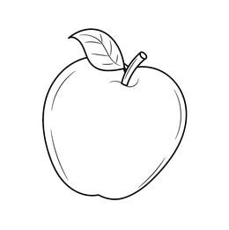

a)

|  |
| --- |
| odnkey |

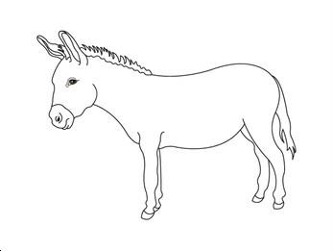

|  |
| --- |
|  |

b)

|  |
| --- |
| Eomnky |

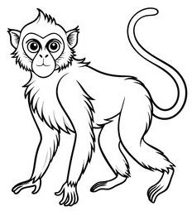

|  |
| --- |
|  |

c)

|  |
| --- |
| aprrot |

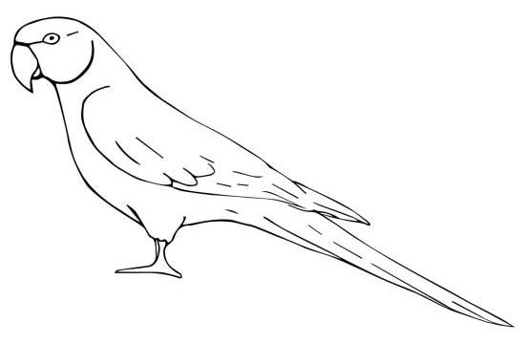

|  |
| --- |
|  |

d)

|  |
| --- |
| sroe |

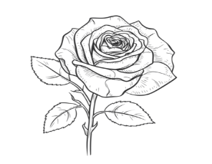

|  |
| --- |
|  |

**Q.No.2]Write vowel and consonant letters. (4)**

|  |  |  |
| --- | --- | --- |
| Words | Vowel letters | Consonant letters |
| tiger |  |  |
| grapes |  |  |
| bucket |  |  |
| mouse |  |  |

**Q.No.3]Rewrite the sentences using pronouns. (4)**

(He / She / It / They)

a) Rima is a good girl. Rima is my sister.

=______________________________

_______________________________

b) My uncle is kind. My uncle is honest too.

=______________________________

_______________________________

c) I have a pet parrot. The parrot is green.

=______________________________

_______________________________

d) The students are on the ground. The students want to play.

=______________________________

_______________________________

**Q.No.4] Write ‘M’ for masculine and ‘F’ for feminine gender.(4)**

a) sister =_________

b) brother =_________

c) son=__________

d) aunt=__________

**Q.No.5] Fill in the blanks with suitable pronouns.(5)**

(He, She, It, They, I)

a)__________am a smart girl.

b)____________are reading now.

c)___________is an apple.

d)____________is my mother

e)___________is her uncle.

**Q.No.6] Answer the following questions.(4)**

a) What is a pronoun?

=____________________________________________________

_______________________________

b) How many letters are there in the English alphabet?

=____________________________________________________

_______________________________

The End